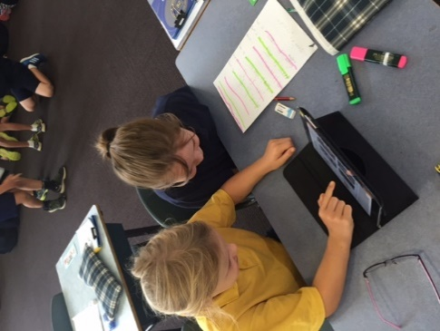

BELMONT PRIMARY SCHOOL

SCHOOL iPad User Agreement: iPad Program 2022



**General Information**

The iPad is to be used as a tool to assist with student learning. It is therefore expected that the device will be maintained in accordance with our school policies and documents. These policies and documents in combination will help to ensure our use of digital technology is done in a manner that maximizes student learning, providing opportunities for our students to work creatively and collaboratively in a safe and future oriented environment. Students and their parents/guardians are asked to carefully read this User Agreement before signing. Any further questions can be directed to your child’s classroom teacher or our Principal, Mr David Houghton.

**1. Student Responsibilities:**

The student is responsible for:

1.1 Keeping the iPad secure when not in use at school by placing it in the classroom’s lockable storage cabinet.

1.2 Ensuring that they bring in their own headphones, which remain at school in their table locker.

1.3 Always using the iPad responsibly at school, in accordance with the school rules. This includes:

* Using the iPads at school as a learning tool. This means using appropriate and relevant apps for the learning activity as directed by the teacher.
* Not touching anyone else’s iPad unless asked to do so by a teacher.
* Ensuring that all communication on the iPad is respectful at all times.
* Not communicating with others through their iPad when at school (unless asked to do so by a teacher as part of a learning activity). This includes Airplay and Airdrop features.
* Ensuring that any photos or videos taken of students and teachers are not published online, unless approved by a teacher.
* Not revealing personal information about themselves or others online using their iPad in anyway, including email addresses, surnames, phone numbers or passwords.
* Alerting a teacher immediately to any inappropriate content or communications on their iPad.
* Ensuring that any account approved to be used on the iPad is used in an appropriate way.
* Ensuring that the App Store is not accessed.

1.4 Following appropriate safety and care procedures as outlined by the classroom teachers, including:

* Handling the iPad carefully, and taking care with the placement of the device at all times.
* When moving with the iPad, ensuring that it is held securely with both hands and is not in use.
* Ensuring that the iPad protective cover and screen protector are left on the device at all times.
* Ensuring that food and drinks are kept well away from the iPad at all times.
* Ensuring that content put on the iPad is not inappropriate or offensive.

Where a student does not fulfil these responsibilities the school will use the Belmont Primary School Consequence for Inappropriate Behaviour Document in deciding the most appropriate consequence or response.

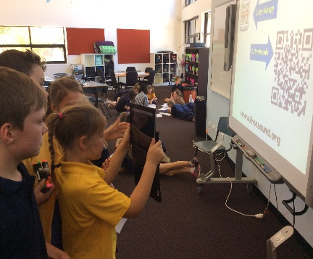

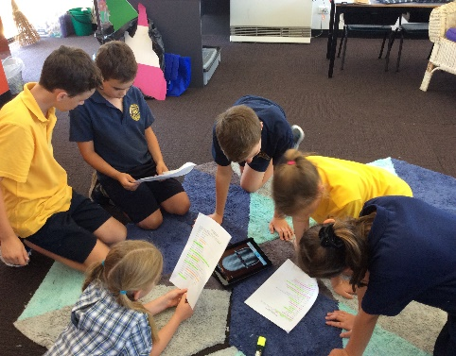

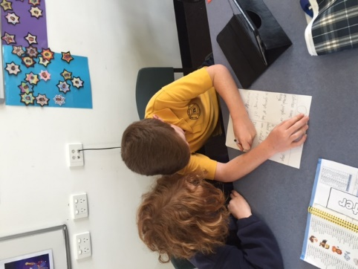

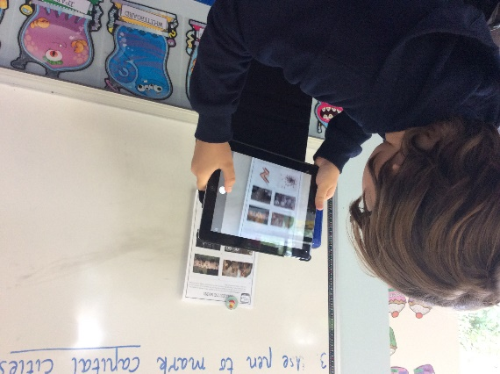

*Agreement adapted and modified with permission of Mandama Primary School*

**This form is to be completed by students and parents/guardians and returned to the classroom teacher please.**

I have read and agree to comply with the

**Belmont Primary School  
 School iPad User Agreement**

I have also read the Belmont Primary School

**Consequences for Inappropriate Behaviour Document.**

I agree to comply with any changes to these policies which I will be

notified of in the future.

I accept my responsibilities and the conditions outlined in this agreement.

Student Name: ____________________________________________________________________

Signature: ________________________________________ Date: ________________________

Parent/Guardian Name _______________________________________________________________

Signature: ________________________________________ Date: ________________________

BELMONT PRIMARY SCHOOL

SCHOOL iPad User Agreement:

iPad Program 2022

