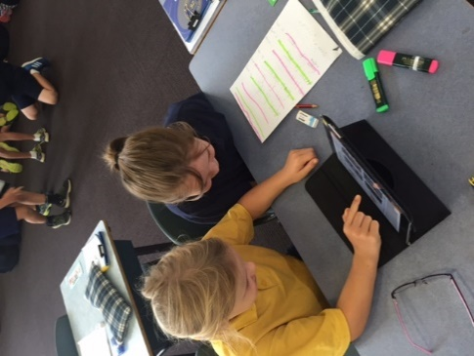

BELMONT PRIMARY SCHOOL

BYOD iPad User Agreement: iPad Program 2022



**General Information**

The iPad is to be used as a tool to assist with student learning. It is therefore expected that the device will be maintained in accordance with our school policies and documents. These policies and documents in combination will help to ensure our use of digital technology is done in a manner that maximises student learning, providing opportunities for our students to work creatively and collaboratively in a safe and future oriented environment. Students and their parents/guardians are asked to carefully read this User Agreement before signing. Any further questions can be directed to your child’s classroom teacher or our Principal, Mr David Houghton.

**1. Student Responsibilities:**

The student is responsible for:

1.1 Ensuring that the iPad has a screen protector and strong protective cover that remains on the iPad at all times.

1.2 Ensuring that their headphones remain at school in their table locker.

1.3 Bringing the iPad to school each day with at least 60% battery life.

1.4 Ensuring that their device and cover is clearly labelled with their name.

1.5 Bringing their school bag containing their iPad into the classroom from 8.45 am every day.

1.6 Keeping the iPad secure when not in use during the school day by placing it in the classroom’s lockable storage cabinet.

1.7 Ensuring that their iPad is packed carefully into their bag before leaving school each day.

1.8 Always using the iPad responsibly both at school and at home, in accordance with the school rules. This includes:

* Using the iPads at school as a learning tool. This means only using appropriate and relevant apps for the learning activity as directed by the teacher.
* Not touching anyone else’s iPad unless asked to do so by a teacher, this includes not sharing their iPad with other students.
* Ensuring that all communication on the iPad is respectful at all times.
* Not communicating with others through their iPad when at school (unless asked to do so by a teacher as part of a learning activity). This includes Airplay and Airdrop features.
* Ensuring that any photos or videos taken of students and teachers are not published online, unless approved by a teacher.
* Not revealing personal information about themselves or others online using their iPad in anyway, including email addresses, surnames, phone numbers or passwords.
* Alerting a teacher or parent/guardian immediately to any inappropriate content or communications on their iPad.
* Ensuring that all content is appropriate to have at school (eg; apps, music, videos etc.)
* Ensuring that any account created on the iPad (that is approved by a teacher or parent) is used in an appropriate way.

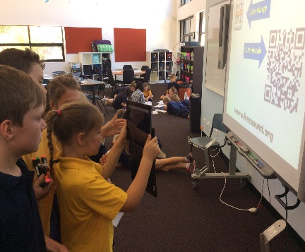

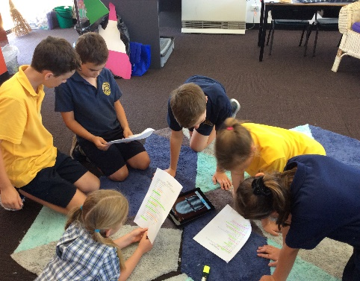

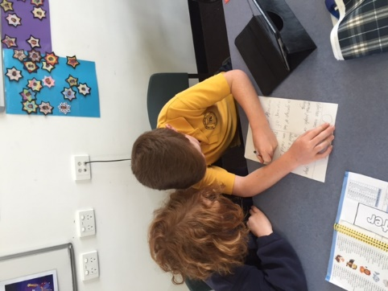

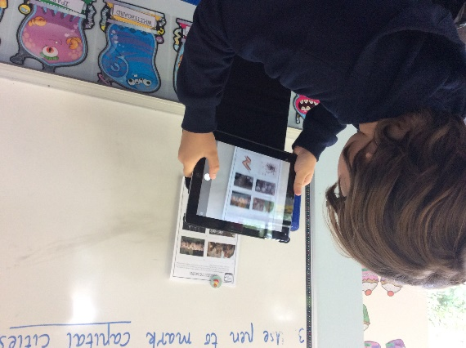

BELMONT PRIMARY SCHOOL

BYOD iPad User Agreement: iPad Program 2016



BELMONT PRIMARY SCHOOL

BYOD iPad User Agreement: iPad Program 2022



1.9 Following appropriate safety and care procedures as outlined by the classroom teachers, including:

* Handling the iPad carefully, and taking care with the placement of the device at all times.
* Handling their school bag carefully and ensuring that the iPad remains in their school bag when moving to and from school.
* When moving with the iPad, ensuring that it is held securely with both hands and is not in use.
* Ensuring that the iPad protective cover and screen protector are left on the device at all times.
* Taking care when packing the iPad into the schoolbags and not placing it underneath heavy items.
* Ensuring that food and drinks are kept well away from the iPad at all times.
* Ensuring that nothing is put on the iPad that is inappropriate or offensive (eg; content or stickers etc.)

1.10 Backing up data securely at home, if desired.

1.11 Ensuring that the App Store is not accessed at school without teacher direction.

1.12 Ensuring that there is enough working storage (minimum 2GB) on the iPad to be able to complete activities each day.

1.13 Ensuring that no file sharing or copyright infringement software or material is stored on the iPad.

Where a student does not fulfil these responsibilities the school will use the Belmont Primary School Consequence for Inappropriate Behaviour Document in deciding the most appropriate consequence or response.

**2.** **Parent/Guardian Responsibilities**

The parents/guardian of students are responsible for:

2.1 Ensuring that the student brings their iPad to school each day.

2.2 Ensuring that the iPad is protected with a strong quality cover and screen protector.

2.3 Ensuring that the iPad provided is kept up to date with the latest Operating System available.

2.4 Ensuring that the iPad is securely backed up at home, if desired.

2.5 Ensuring that the required Apps are downloaded and available to be used.

2.6 Ensuring that all content on the iPad is appropriate for the student to have at school (eg; apps, music, videos etc.)

Any disputes regarding damage or loss that has occurred at school will be mediated by the school Principal, on a case by case basis.

*Agreement adapted and modified with permission of Mandama Primary School*

**This form is to be completed by students and parents/guardians and returned to the classroom teacher please.**

I have read and agree to comply with the

**Belmont Primary School BYOD iPad User Agreement**

I have also read the Belmont Primary School

**Consequences for Inappropriate Behaviour Document.**

I agree to comply with any changes to these policies which I will be

notified of in the future.

I accept my responsibilities and the conditions outlined in this agreement.

Student Name: ____________________________________________________________________

Signature: ________________________________________ Date: ________________________

Parent/Guardian Name _______________________________________________________________

Signature: ________________________________________ Date: ________________________

BELMONT PRIMARY SCHOOL

BYOD iPad User Agreement:

iPad Program 2022

