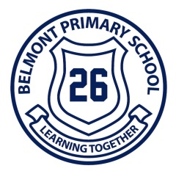
Belmont Primary School

Dear Parents,
Welcome to Belmont Primary School! Belmont Primary School is a special place and I thank you for considering our school for your child’s education. We understand just how precious each and every child is and take great pride in working with parents to ensure that every child enjoys a highly successful primary education.

Starting school is always an exciting time for both students and parents. Prep year is a very special year for your child when the foundations are laid for a happy, rewarding and successful school life. As your child grows and develops, each new year will bring new and exciting challenges. Our teachers are equally excited by this challenge and you’ll find that the teachers will become a very important part of your child’s life.

As parents, you have already played an important role in your child’s learning, helping them to develop emotionally, socially, physically and academically. The home environment you create has a powerful influence on children’s success and level of achievement in learning. If parents see themselves as educators, children learn better. At Belmont Primary School, parents have the opportunity to significantly participate in the education of their children. This can be achieved in many ways, from helping in classrooms and on excursions to being part of the formal decision making bodies in the school.

This booklet contains further information about our school, organisation and procedures. Please read it carefully and keep it for future reference.

I look forward to working with you.

Regards

David Houghton
Principal
Belmont Primary School

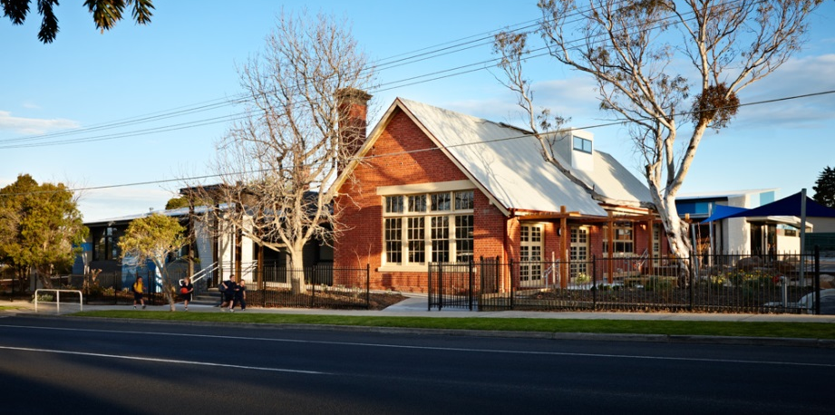

BELMONT PRIMARY SCHOOL

Postal Address P.O. Box 471
Mt. Pleasant Road
Belmont. 3216.
Telephone (03) 5243 2972
Web: www.belmontps.vic.edu.au
Principal Mr David Houghton

TERM DATES FOR 2020
Term 1 29th January to 27th March
Term 2 14th April to 26th June
Term 3 13th July to 18th September
Term 4 5th October to 18th December

TERM DATES FOR 2021
Term 1 27th January to 1st April
Term 2 19th April to 25th June
Term 3 12th July to 17th September
Term 4 4th October to 17th December

PREP CHILDREN - Attendance times.
Attendance times for February

Special arrangements are made during February to allow the Prep children to adjust to school life. Prep students attend school:

Monday, 9.00 am - 3.30 pm
Tuesday, 9.00 am - 3.30 pm
Thursday, 9.00 am - 3.30 pm
Friday, 9.00 am - 3.30 pm

Prep children do not attend school on any Wednesday during February. Teachers will however, make an appointment for parents to bring their child to school for assessment purposes on a Wednesday during February.

SCHOOL HOURS
School commences each morning at 9:00 am. Teachers supervise students in the school grounds from 8.45 am to 9.00 am and from 3.30pm until 3.45 pm.

It is expected that children will arrive at school after 8.45 am and will have been collected from school by 3.45 pm.

In the early weeks of the school year Prep children should be collected from their classroom until they become familiar with the school and its routines. By mid-March however, we find it is best if parents meet children at a predetermined gate or door.

BELL TIMES
Normal Bell times are as follows :
9.00 am. - Commencement of morning session
11.00 am. - Morning recess
11.30 am. - End of morning recess
1.30 pm. - Lunch supervised in classroom
1.40 pm. - Lunch recess
2.30 pm. - Commencement of afternoon session
3.30 pm. - Dismissal

PROFESSIONAL TEACHING STAFF
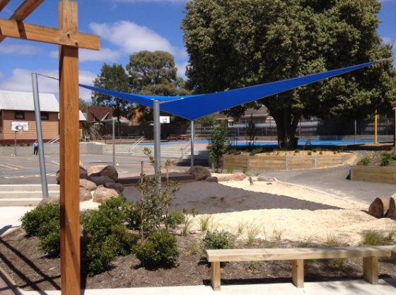
At Belmont Primary School we have a vibrant and experienced teaching staff who demonstrate their commitment to the children on a daily basis. Features of their teaching include:
- A genuine love of children.
- A commitment to excellence in education and in meeting the needs of the individual.
- A commitment to ongoing professional development.
- An obvious enthusiasm for their role.
- A commitment to student welfare.

ASSEMBLIES
A whole school assembly is held each Friday morning. Parents are always welcome to attend these assemblies to hear news and information about weekly ‘happenings’, school events and student achievements. This is also the time when we present children with various awards. Teachers will endeavour to contact you if your child is to receive an award to ensure you have the opportunity of being there if able to do so.

ATTENDANCE
It is important that children attend regularly and punctually from an early age. We know that regular attendance is essential for children to achieve to the best of their ability. We also know that if children are genuinely unwell the best place for them is at home where they can recover.

In the event your child is absent, please log in to the Compass program with your unique user name and password, which we will supply. The instructions for you to do this will be provided with your login details

BEFORE / AFTER SCHOOL CARE
We offer an outstanding Before and After School Care Program as a service to our families. Before School Care is provided from 7.00 to 9.00am and After School Care is provided from 3.30pm to 6.30pm each weeknight. All families are entitled to a child care benefit through Centre Link to offset the cost of this service. Please contact the After School Care Co-ordinators (School Support Services) on 0488 662 783 for further information.
Further information can be found at http://www.schoolsupportservices.com.au/oshc_programs.htm

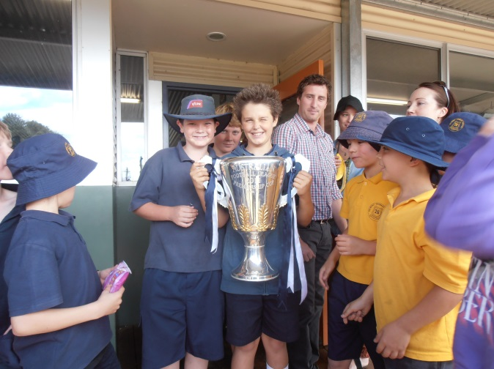
CLOTHING
Our children proudly wear a school uniform. The uniforms look smart and make things much easier for the parents. Please put children's names on all articles of clothing, including hats, coats, jumpers and all school belongings. It also helps your child develop independence if you teach them to look after and take responsibility for their own belongings. All uniforms can be purchased from PSW Geelong.

LOST PROPERTY
Every now and again a child will lose a piece of clothing, particularly jumpers. Finding the owner is always easy if the item of clothing has the owner’s name on it. If your child loses anything, parents are able to come to school to check lost property or inform the class teacher. Lost property is stored on the Lost Property stand at the entrance to the BER building. Property not claimed at the end of the term will be given to a local charity. A name on your child's clothing will be of great assistance when items are lost.

COMMUNICATION WITH PARENTS
Newsletter
The school newsletter informs parents of news, events or happenings around the school. It is published every Thursday. This is a very important way that the school uses to communicate with parents.

Reporting
Parent / Teacher relationships are fostered by :
- "Get to know you" meetings held in late February/early March.
- Individual discussions which can be arranged between parents and the Principal, and/or class teacher at any time.
- Written reports distributed in June and December.
- In June the reports will be issued prior to the midyear Parent/Teacher Interviews.
- In December, parents will be given the opportunity to make an appointment to discuss the report with the teacher if they require it.

Importantly, parents are always able to make an appointment to see teachers or the principal. Our school operates on an “open door” policy where parents are always welcome.

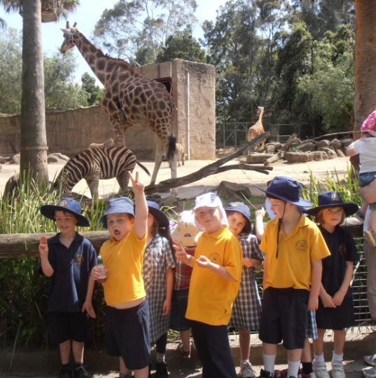
EXCURSIONS
Excursions are a vital part of our school's educational program. It is therefore important that each child attends so that they may participate fully in follow up programs. Prior to excursions, a notice will be sent home outlining all relevant details and costs as well as requesting parental permission for participation.

EARLY COLLECTION OF CHILDREN
If you are taking your child home early from school please notify the class teacher. There is also a book at the office where children importantly need to be signed out if leaving earlier than usual. Equally important parents wishing to connect with their children through the day need to first come through the office please.

PARENT INVOLVEMENT
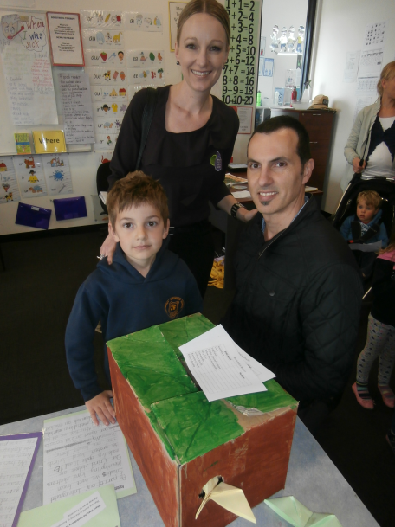
This school welcomes the involvement of parents in many different ways. Indeed, our school is renowned for its high level of parent participation. Requests for parents to contribute in areas of interest or expertise are usually made through the school newsletter. We may offer from time to time programs for parents wishing to help in classrooms.

In a more formal way parents are encouraged to join the following:
School Council, Parents' Club and Special Working Parties.

School Council
The School Council at this school is made up of seven elected parents, three elected staff members, plus the Principal and up to two co-opted members.
It is the focal point for shared decision making at the school. School Council responsibilities concern areas such as curriculum, finance, facilities, school community relations, policy development and promotion.

Parents' Club
This group meets regularly and is a wonderful and important part of the school. The Parents’ Club is involved in planning special events and in providing help and assistance around the school in a variety of ways. It is a great place for parents to start their involvement with the school. Members of the Parents Club are committed supporters of the school and also provides a wonderful social opportunity for parents.

PUPIL HEALTH
The school should be notified if children have asthma or other health problems such as impairments in sight or hearing. This is necessary so that the adequate safeguards may be taken to protect the health of the child. All children are to participate in physical education and sport unless specifically excused.

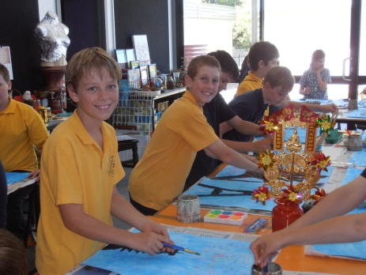
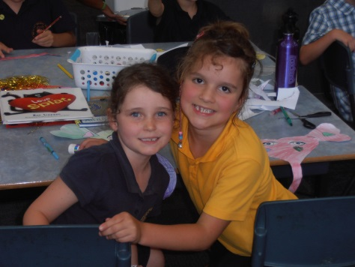
A school nurse conducts a health check for Prep children if identified by their parent during their first year at school.

EMERGENCY INFORMATION
It is essential that the school know your current home and business phone numbers and the name and phone number of the person who is to look after your child in your absence should they become ill at school.

Please advise the school of any changes of address, telephone numbers or emergency contact details as soon as possible.

INFECTIOUS DISEASES
Children suffering from infectious diseases shall be excluded from school for the period stated below or until a medical certificate has been produced.

Measles Until at least five days after the rash appears or until receipt of medical certificate.
German Measles Until fully recovered and at least five days from the onset of the rash.
Whooping Cough Two weeks or with a medical certificate.
Diphtheria Medical certificate required.
Chicken Pox Until fully recovered.
Mumps Until fully recovered.
Conjunctivitis Until discharge from eyes has ceased.
Scabies Until appropriate treatment has commenced.
Infectious Hepatitis Medical certificate required.
School Sores &
Ringworm To remain at home unless sores are treated and covered.
Head Lice Until appropriate treatment has commenced.

CHILDREN REQUIRING MEDICATION
Where medication for children is prescribed, parents are requested, wherever possible, to make arrangements for the administration of medicine outside school hours.

If a child is dependent on particular medication to control an illness, staff are able to assist. Parents will need to supply the medication in a suitable container clearly marked with the student’s name and complete a prescribed Medication Form available at the office.

STUDENT IMMUNISATION
The Health Regulations 1990 were introduced to raise the immunisation coverage of children entering school. The legislation does not make immunisation compulsory, however, certification of immunisation status is compulsory and this must be on the prescribed certificate issued please.

STUDENT LEADERSHIP
Children at Belmont Primary School are encouraged to develop their leadership qualities and are given every opportunity to do so. The children elect School Captains which is a very significant leadership role and honour.
We also run a House System (Regent, Thomson and Pleasant) with elected student House Captains and Vice Captains. In addition to these positions, children elect a Junior School Council which then meets regularly and makes a very worthwhile contribution to the running of the school.

SCHOOL UNIFORM
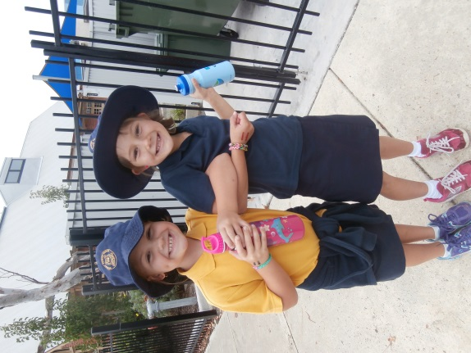
Belmont Primary School has an official school uniform which all students are expected to wear each day. (Including excursions and sporting activities unless otherwise notified.)
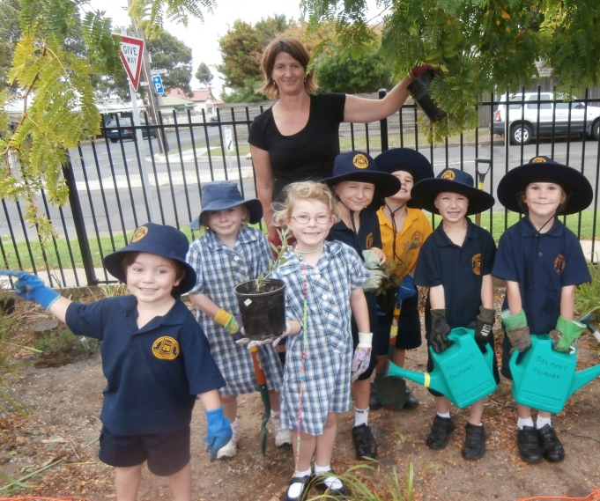
School uniforms can be purchased through PSW Geelong. School colours are Navy Blue and Gold.

HOW YOU CAN HELP YOUR CHILD’S LEARNING
You can provide your children with a background for successful learning by:
- Asking them to help with tasks.
- Providing a wide variety of materials so your child can draw, paint, cut, make things.
- Reading to your child daily.
- Telling them stories
- Taking them on outings and discussing things seen and heard.
- Listening to their questions and providing honest answers.
- Encouraging them to ask questions.
- Being interested in what your child does at school and talking about their day.
- Talking about your child’s belongings with them so they readily recognise them.
- Teaching children to say their first name and their surname.
- Proudly displaying work or art brought home from school.

HOW YOU HELP WITH READING, WRITING, SPELLING AND MATHEMATICS
Language learning is a natural process. Children learn to speak, write and read with constant exposure to good models complemented by effective teaching programs.

Children progress at individual rates and it is normal for them to begin to write stories and to read at different ages.

Mathematics
- Talk with your child about maths in every day things.
- Involve children in cooking - measuring, counting, weighing, sharing.
- Discuss patterns in plants, leaves, paving, counting, colors.
- Use concepts such as on, in, under, over, above, below, beside etc.

Writing (story writing)
- Encourage ‘invented writing’. Ask your child to read what they have written. Write their story underneath and read it through with them.
- Draw attention to environmental print. Eg. Signs
- Encourage attempts to spell words - build up a list of known words and keep these in an envelope or on flash cards. Teach your child to ask ‘is this how you spell . . ? so that they begin use their knowledge of language. Praise their attempts and show them which letters they placed correctly and show them the correct spelling.

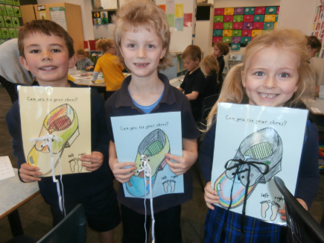
Reading
- Share books with your child every day.
- Point along the line of print as you read to develop left to right scanning.
- Discuss pictures in books. Children use pictures as a guide.
- Look at the pictures first and encourage children to predict the storyline before you read the book.

Handwriting
- Allow children time to experiment with writing - scribble is a normal stage of writing.
- Ask children to tell you about their scribbles / pictures. Write a sentence about them.
- Teach children to write their name beginning with a capital letter.

CHILDREN STARTING SCHOOL CAN BE ENCOURAGED TO:
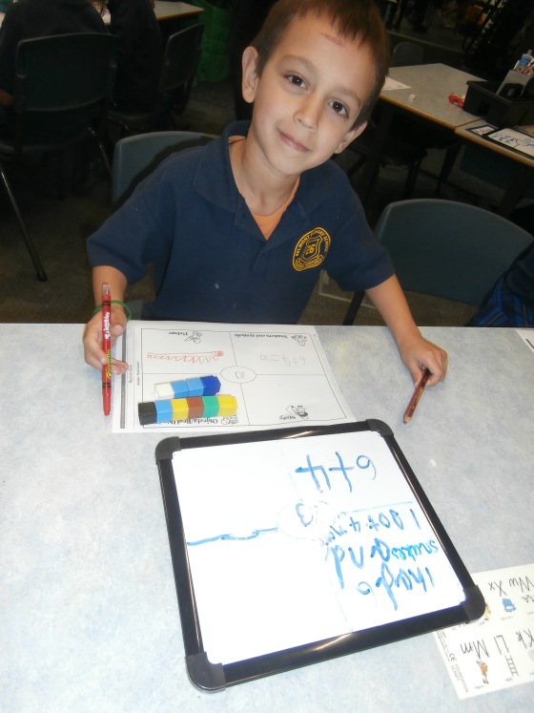
- Speak clearly and confidently to other children and adults.
- Eat lunch independently.
- Use the toilet - washing hands afterwards.
- Sit quietly and listen to a short story or piece of music.
- Take off and put on jumpers, shoes etc. (willing to try tying shoelaces).
- Cooperate with others - take turns, share etc
- Understand that they should respect things that belong to others.
- Realise that they will have to share the teacher’s attention with other children.
- Leave their parents confidently.
- Accept that they cannot always get their own way.
- Accept responsibility for their own belongings.
- Play independently.
- Finish games, tasks and pack up afterwards.
- Understand that print has meaning.
- Know their name and address well enough to repeat it when necessary.
- Recognise their own name when written.

CURRICULUM
Through the provision of a diverse and interesting curriculum, students are both challenged and motivated to view learning as a life long process of self-improvement. Our programs instill confidence, creativity, self discipline and a strong sense of social responsibility.

AUSVELS is a curriculum framework which heaps to define key learning areas, skills and capabilities taught in school.
The three Domains include:
- Physical, Personal and Social learning
- Discipline based Learning
- Interdisciplinary Learning

See details @ http://ausvels.vcaa.vic.edu.au

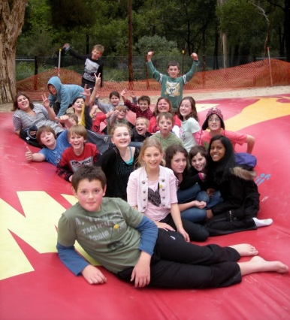
Your child will also have specialist lessons in P.E, visual art, STEM, performing art and Italian. In recent years the Department have provided a library bag for all prep children to carry their books to and from school.

Each child also requires an art smock. An old shirt will provide good protection for school clothes but we recommend elasticised sleeves and neck. Please ensure the art smock is named.

SPECIAL PROGRAMS
In addition to the above, we run numerous special programs including: Debating, Buddies, Swimming, Camps, Life Education, Intervention, Bravehearts, Gymnastics, Bike Education, Junior School Council, Preparation for Puberty and many more.

DISCIPLINE
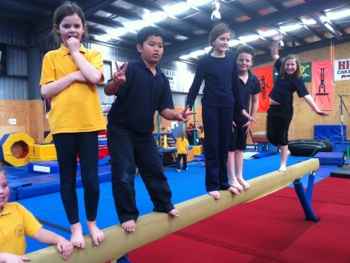
Key values.
Our school community believes that this school should provide a learning environment which aims to ensure that each student can achieve to their maximum potential from the school experience. Our belief is that happy children make great learners and provide a learning environment that encourages this. The focus is more on catching children being good and highlighting positive behaviours than on constantly talking about what is not allowed.

Our student code of conduct aims to provide a safe and supportive learning environment that builds student confidence, a valuing of self and the worth of others and a sense of belonging and seeks to develop a learning community committed to the key values of:
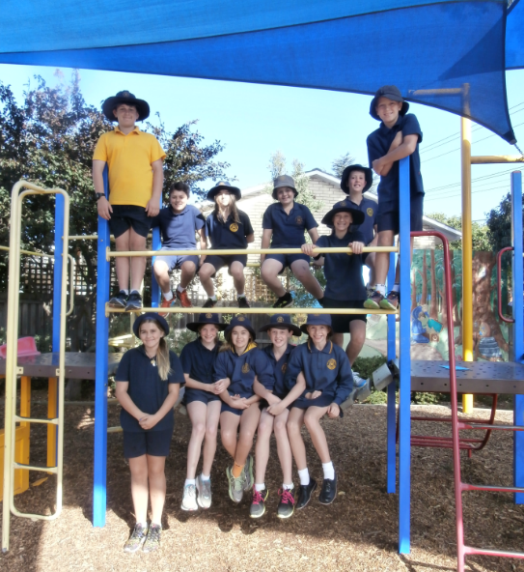
- Honesty
- Respect
- Learning
- Responsibility
- Courage
- Community
- Principles

Belmont Primary School’s Student Code of Conduct is guided by the following principles:
- All children have the right to be safe.
- All children have the right to be treated with respect.
- All children have the right to work and play in a secure environment without interference, intimidations, harassment, bullying or disruption.
- All children are encouraged to be polite, courteous and well mannered.
- Parents have a right to expect that their child will be educated in a secure environment where care, courtesy and respect for others are encouraged.
- Parents have an obligation to support the school in its efforts to maintain a productive learning and teaching environment.
- Teachers should expect to be able to teach in an atmosphere of order and cooperation.
- The principal and staff will fairly, reasonably and consistently implement the Student Code of Conduct.

School Rules
There are five basic school rules:
- Move and play safely.
- Care for yourself, others and property.
- Resolve problems calmly, sensibly and fairly.
- Respect others through your speech and manners.
- Work to the best of your ability and allow others to do the same.

